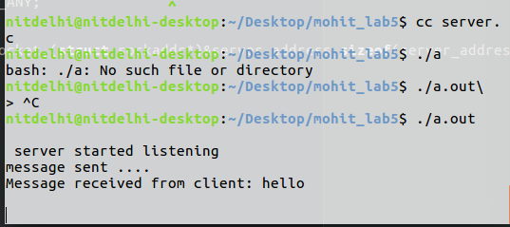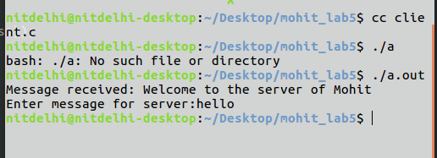

#include<sys/socket.h>

#include<netinet/in.h>

#include<arpa/inet.h>

#include<stdio.h>#include<sys/socket.h>

#include<netinet/in.h>

#include<arpa/inet.h>

#include<stdio.h>

#include<stdlib.h>

#include<unistd.h>

#include<errno.h>

#include<string.h>

#include<unistd.h>

#include<sys/types.h>

int main(int argc , char* argv[]){

// define server socket

int server_socket;

server_socket=socket(AF_INET,SOCK_STREAM,0);

// define server address

struct sockaddr_in server_address;

server_address.sin_family= AF_INET;

server_address.sin_addr.s_addr= INADDR_ANY;

server_address.sin_port= htons(64000);

// bind

bind(server_socket,(struct sockaddr*)&server_address,sizeof(server_address));

listen(server_socket,5);

printf("\n server started listening\n");

while(1){

int client_socket;

client_socket=accept(server_socket,NULL,NULL);

char* msg="Welcome to the server of Mohit";

write(client_socket,msg,strlen(msg));

printf("message sent ....\n");

char buff[256];

read(client_socket,buff,sizeof(buff));

printf("Message received from client: %s\n",buff);

char* p=strstr(buff,"END");

if(p!=NULL){

printf("Serevr is going to off\n");

break;

}

}

}

#include<stdlib.h>

#include<unistd.h>

#include<errno.h>

#include<string.h>

#include<unistd.h>

#include<sys/types.h>

#include<fcntl.h>

int main(int argc , char* argv[]){

// define client socket

int client_socket;

client_socket=socket(AF_INET,SOCK_STREAM,0);

// define client address

struct sockaddr_in server_address;

server_address.sin_family= AF_INET;

server_address.sin_addr.s_addr= INADDR_ANY;

server_address.sin_port= htons(64000);

int connection_status=connect(client_socket,(struct sockaddr*)&server_address,sizeof(server_address));

if( connection_status ==-1){

printf("Error happen\n");

exit(1);

}

char buff[256];

read(client_socket,buff,sizeof(buff));

printf("Message received: %s\n",buff);

char *msg;

msg=(char*)malloc(sizeof(char)*50);

printf("Enter message for server:");

fgets(msg,50,stdin);

write(client_socket,msg,strlen(msg));

close(client_socket);

return 0;

}